344C5
Popa Iulia

Laboratory 9 - Memory, CPU and Network Monitoring (Windows)

Task 01. RAM Monitoring
Windows Performance Recorder & Analyzer:
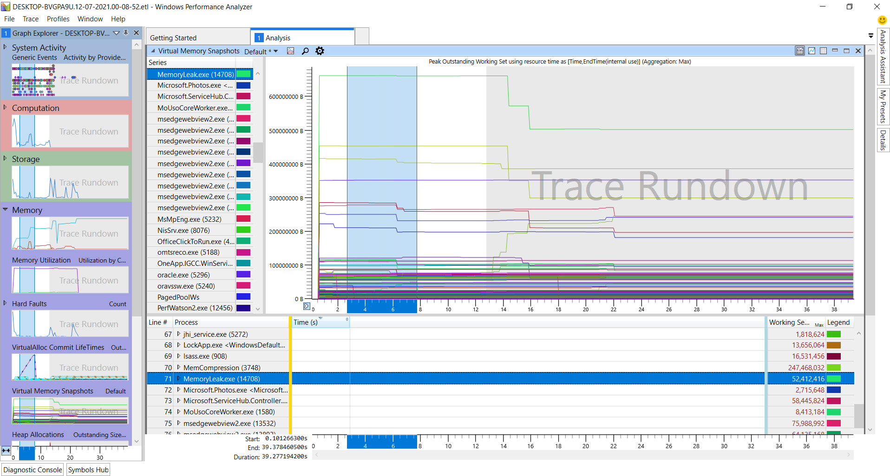

Used memory keeps increasing because the program allocates a new memory block with each iteration. The memory isn’t deallocated, neither reused.

VMMap:
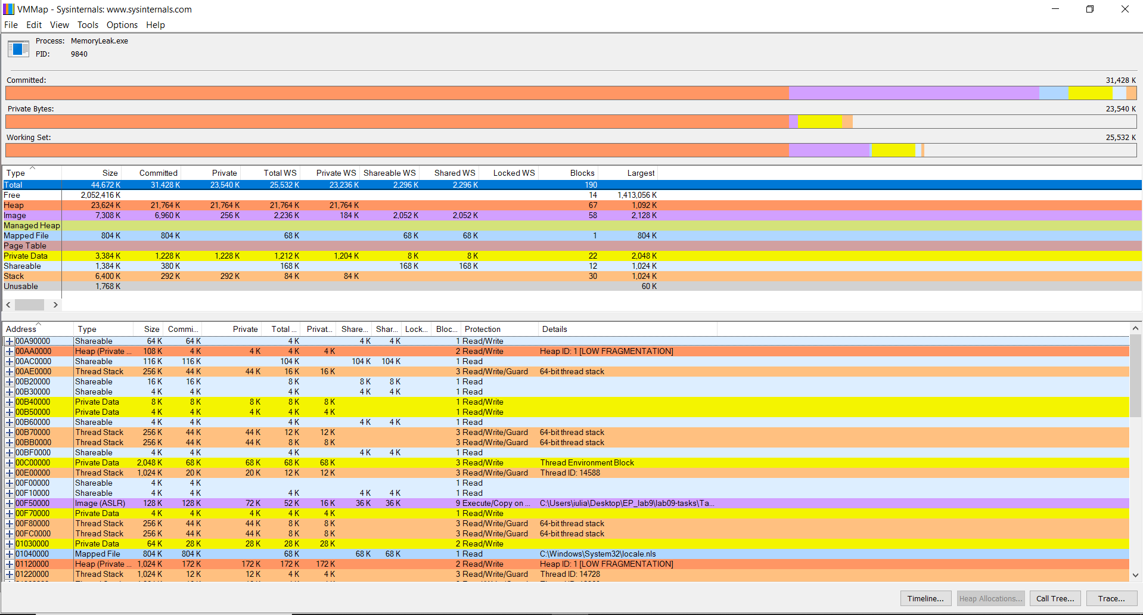
The program shows the number of allocated blocks, their sizes, and the addresses where they are (we can also see memory leaks).

Visual Leak Detector:
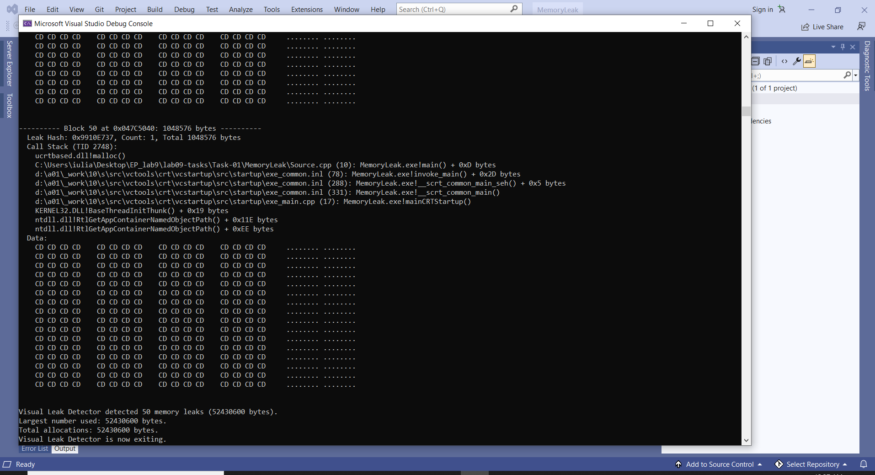

Task 02. CPU Monitoring

Task Manager (CPUUsage):
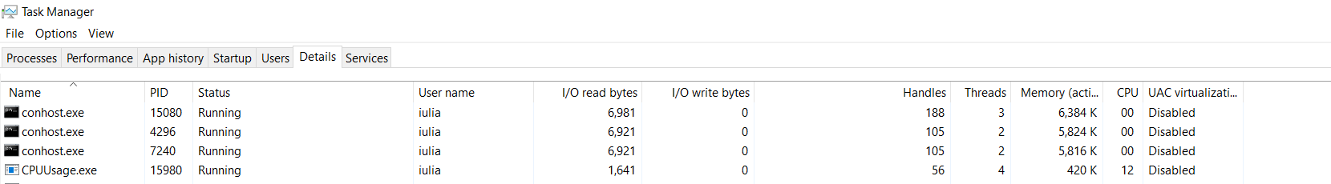

Windows Performance Recorder & Analyzer (CPUUsage):
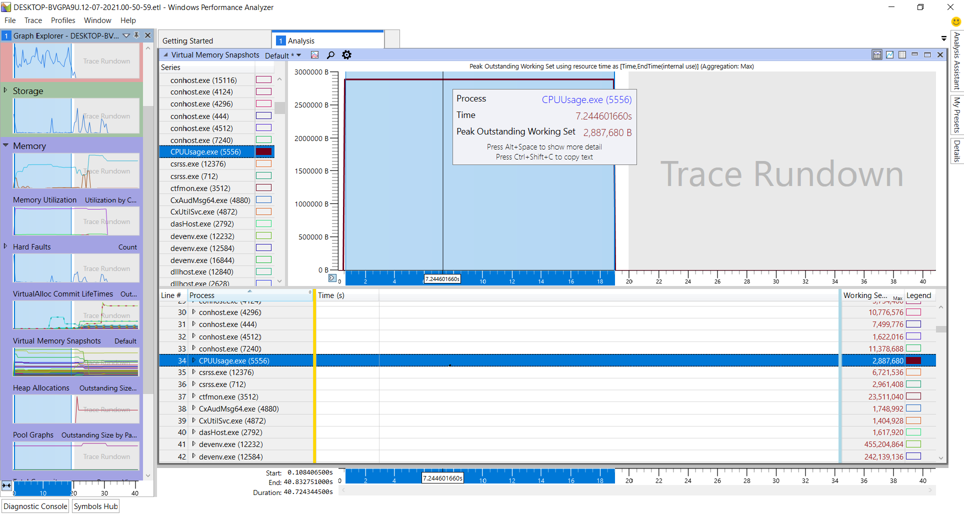

Windows Performance Recorder & Analyzer (EvenimenteProcMon):
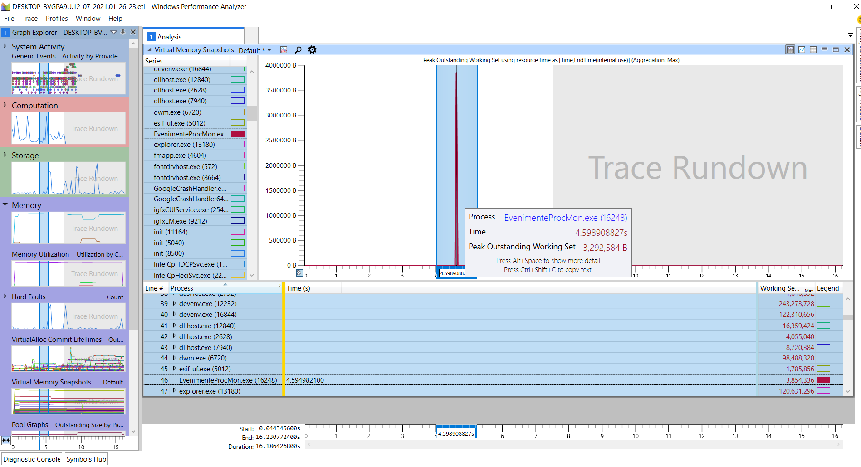
Process Monitor & CVS file:
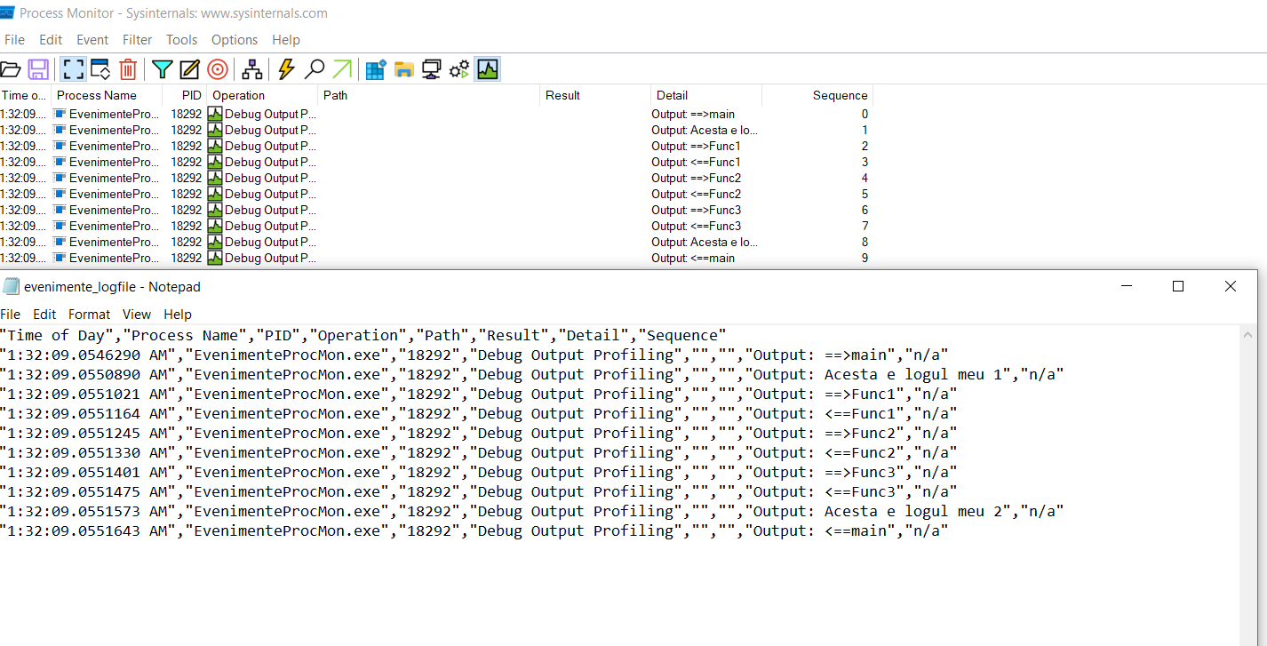
Python parser:
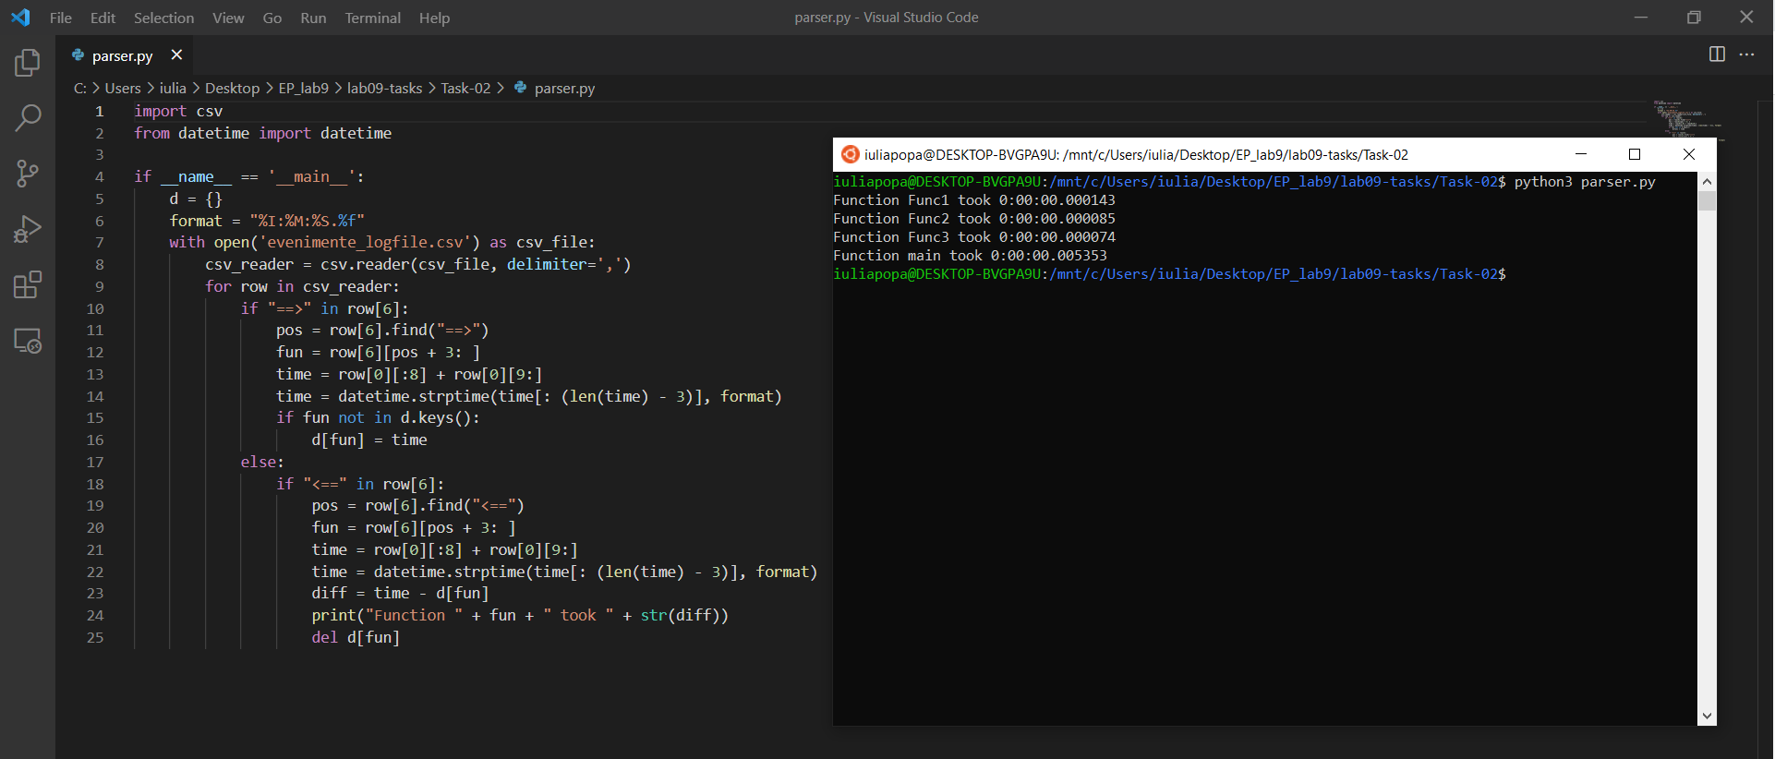
Checking if there are the symbols “==>” or “<==”, I extracted the function’s name and the time. If the function is entered, it is added to the dictionary, else if it is exited, the function is removed from the dictionary and the time interval is calculated. (My English has beaten me this morning.)

Task 03. Network Monitoring

Task Manager:
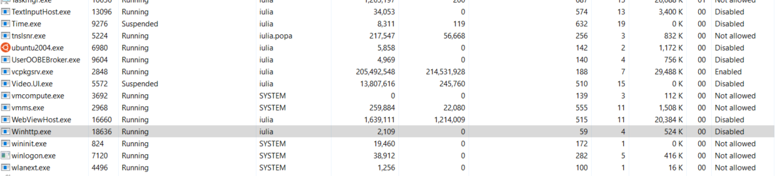

Windows Performance Analyzer & Recorder:
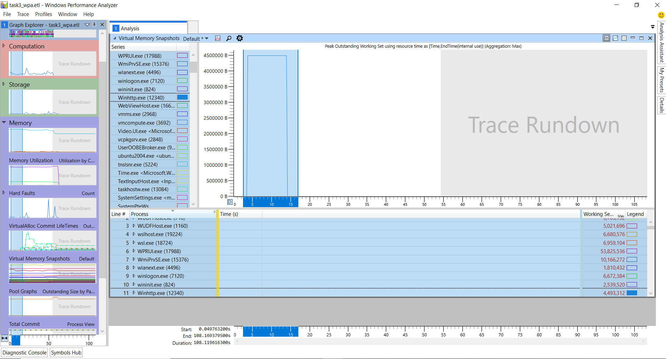

Microsoft Network Monitor:
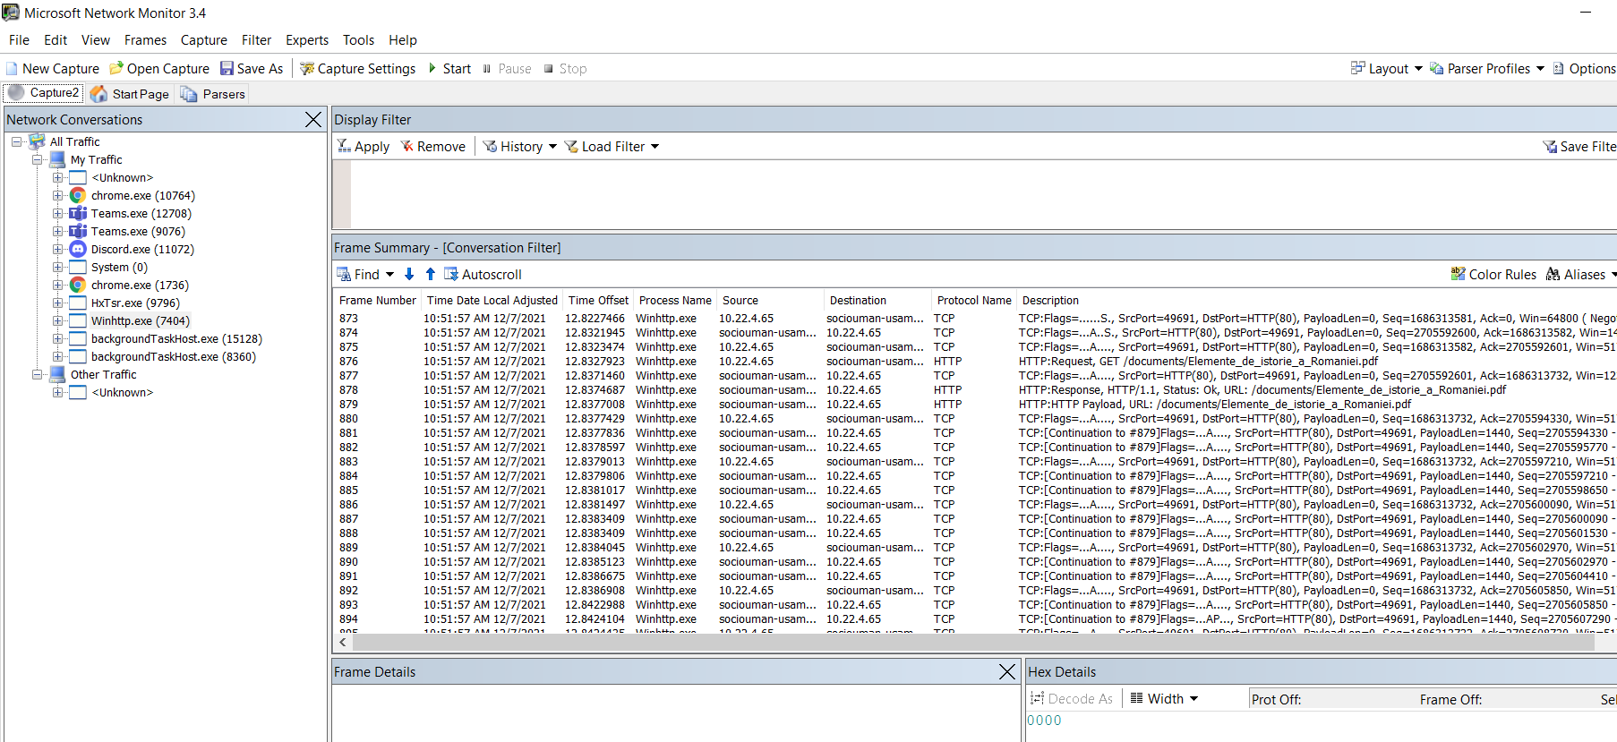
Ping command and Wireshark:
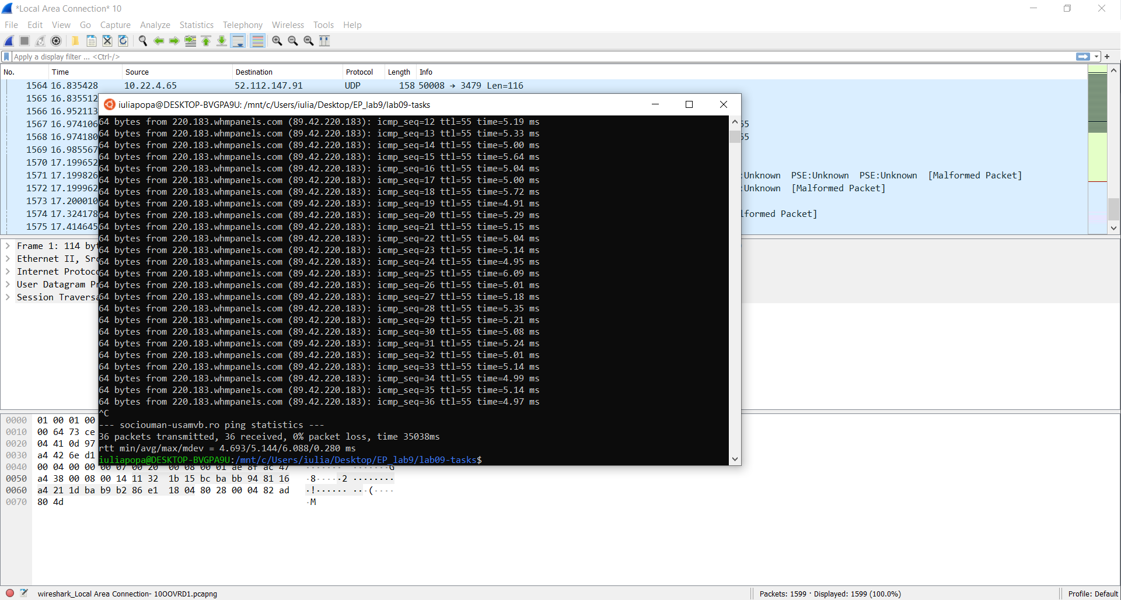

Filter for IP address:
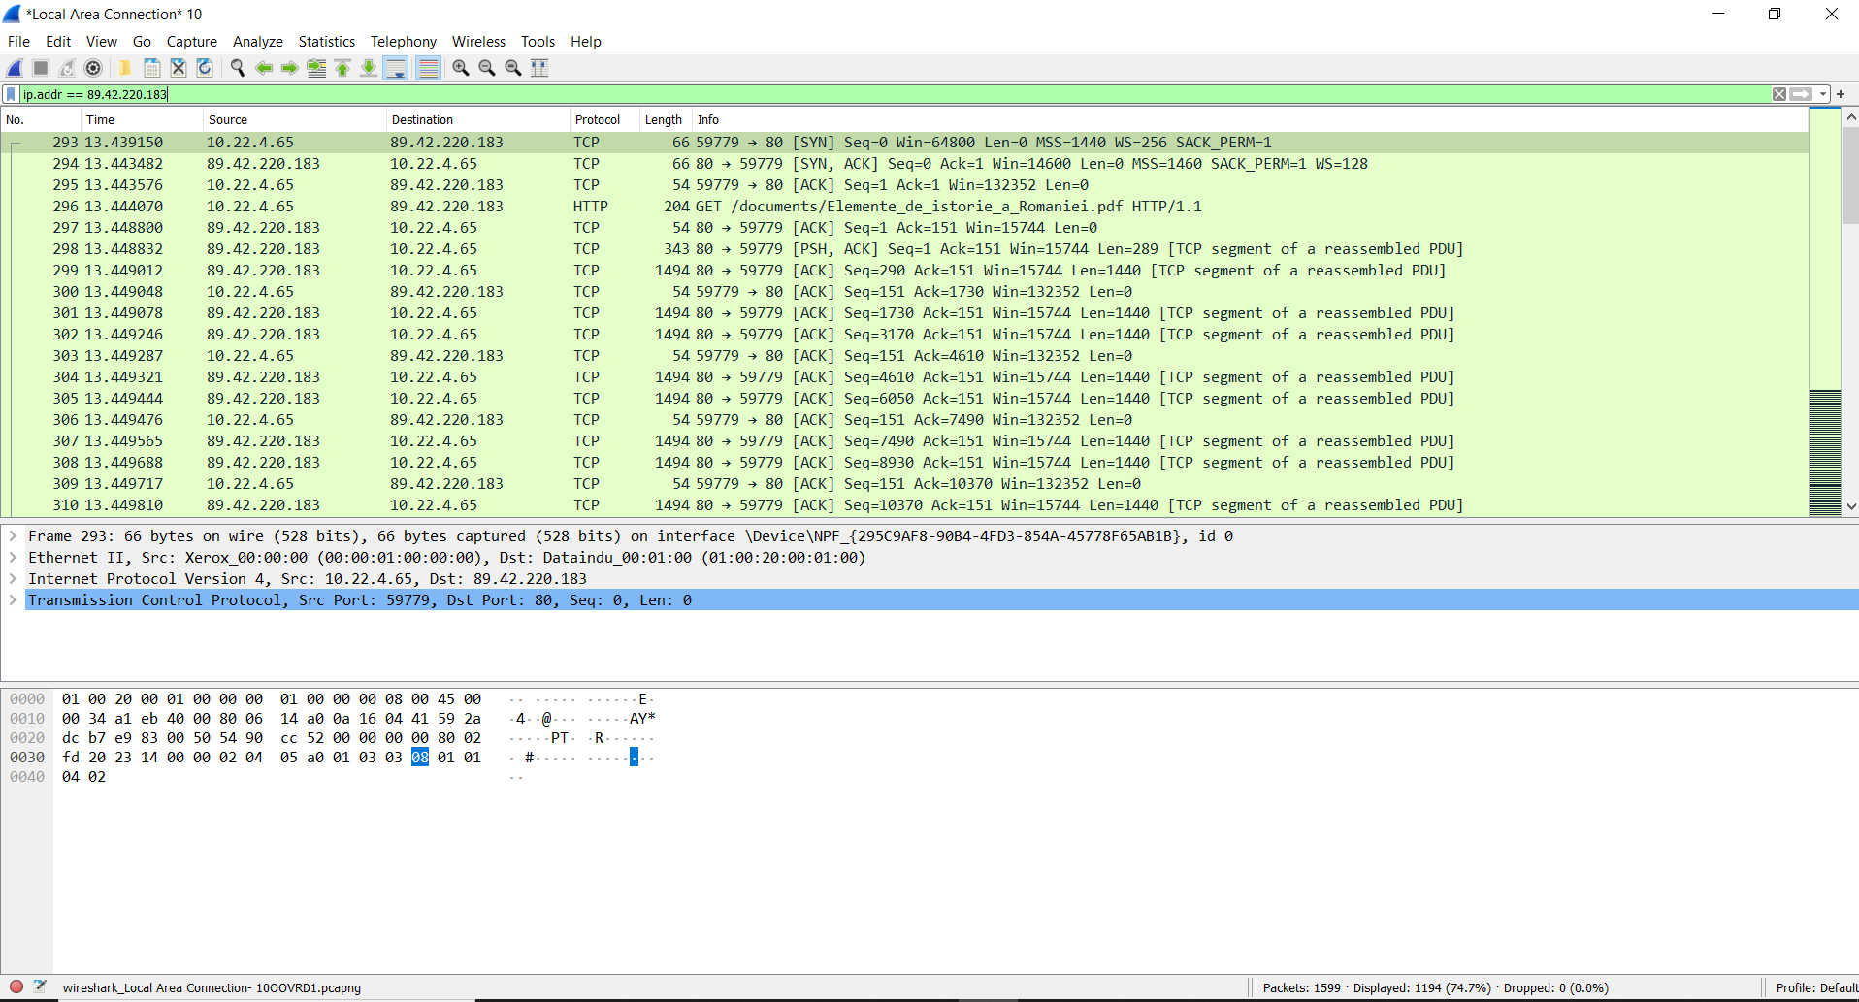

HTTP request (Follow->TCP Stream):
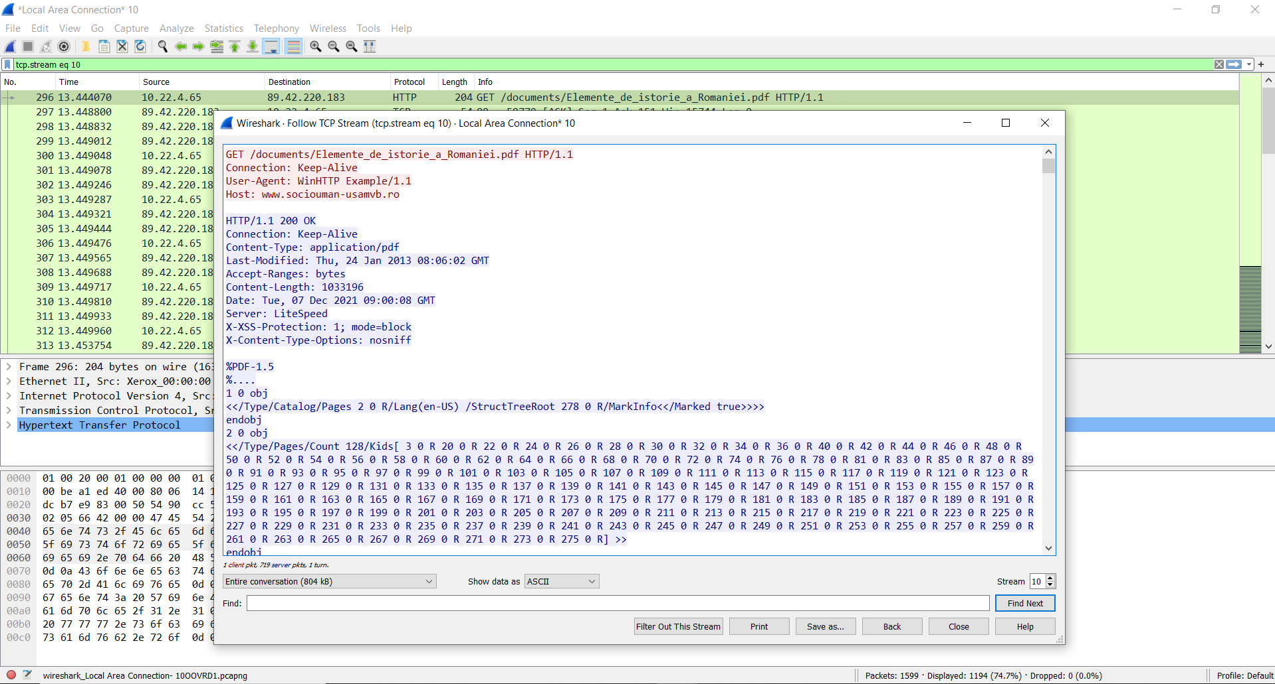

Followed the steps and obtained a PDF that contains 128 pages:
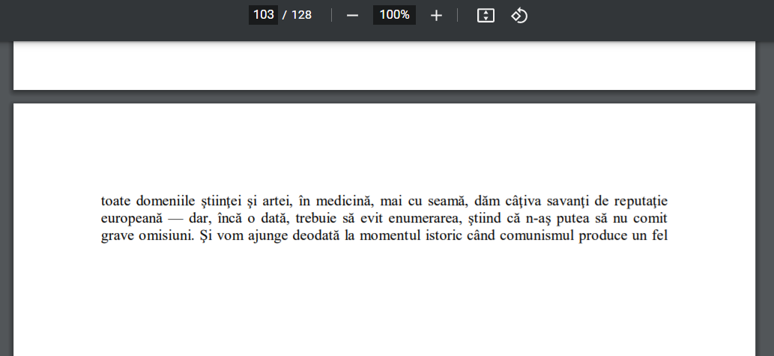
Thank you, EP team, very cool info!🤨

Tadaaaam! 🎉🎉🎉🎉🎉🎉🎉🎉🎉

Task 04. Feedback:
